DBMS ASSIGNMENT – 3

SEQUENTIAL QUERY LANGUAGE

***Roll Number: U19CS012***

***Name: BHAGYA VINOD RANA***

***Q1)*** Create a table **Student** with fields

RollNo Number (6) Primary key

Name Character (25)

Semester Number (3)

DOB Date

AdmissionDate Date

HostelRoom Number (5) (Null values allowed)

Insert 10 Rows in the above created table.

**SQL-Code [**SQLite 3.29.0**]:**

BEGIN TRANSACTION;

CREATE TABLE STUDENT(

    roll_no integer PRIMARY KEY,

    name text,

    semester integer,

*-- YEAR MONTH DAY [Important Mistake!]*

    date_of_birth DATE,

    admission_date DATE,

    hostel_room integer

*-- Null Values also Allowed in Hostel Room*

);

*-- Insert 10 Rows in the above created table.*

INSERT INTO STUDENT VALUES(

    101,

    'Bhagya',

    4,

    '2001-01-02',

    '2001-02-03',

    104

);

INSERT INTO STUDENT VALUES(

    201,

    'Nobita',

    3,

    '2001-03-04',

    '2001-04-05',

    745

);

INSERT INTO STUDENT VALUES(

    103,

    'Doraemon',

    5,

    '2001-05-06',

    '2001-06-07',

    450

);

INSERT INTO STUDENT VALUES(

    204,

    'Shizuka',

    4,

    '2001-07-08',

    '2001-08-09',

    789

);

INSERT INTO STUDENT VALUES(

    150,

    'Sunio',

    4,

    '2001-09-02',

    '2001-10-03',

    912

);

INSERT INTO STUDENT VALUES(

    612,

    'Gian',

    3,

    '2000-11-04',

    '2001-12-05',

    312

);

INSERT INTO STUDENT VALUES(

    107,

    'Kiteretsu',

    4,

    '2001-01-06',

    '2001-02-07',

    390

);

INSERT INTO STUDENT VALUES(

    118,

    'Shinchan',

    2,

    '2001-03-08',

    '2001-04-09',

    881

);

INSERT INTO STUDENT VALUES(

    190,

    'Harry',

    6,

    '2000-05-02',

    '2001-06-03',

    654

);

INSERT INTO STUDENT VALUES(

    210,

    'Salman',

    4,

    '2000-07-04',

    '2001-08-07',

    981

);

*-- Saving the Work*

COMMIT;

*-- 1. Student table with all columns and rows.*

SELECT * FROM STUDENT;

*-- 2. Student details with columns Roll number and Name only.*

SELECT roll_no, name FROM STUDENT;

*-- 3. Student details of all the students who are in 4th semester.*

SELECT * FROM STUDENT WHERE semester==4;

*-- 4. Student details of all the students whose roll number is between 100 to 200.*

SELECT * FROM STUDENT WHERE roll_no>=100 and roll_no<=200;

*-- 5. Student details of all the students whose DOB is greater than 1st jan 2001.*

SELECT * FROM STUDENT WHERE date_of_birth > '2001-01-01';

Display the below details.

1. Student table with all columns and rows.

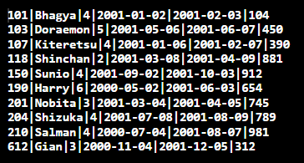

2. Student details with columns **Roll number** and **Name** only.

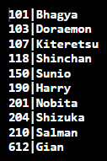

3. Student details of all the students who are in **4th semester**.

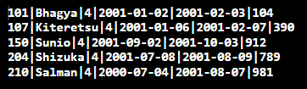

4. Student details of all the students whose **Roll number** is Between **100 to 200**.

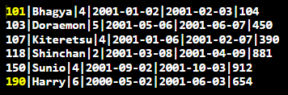

5. Student details of all the students whose **DOB** is greater than **1st Jan 2001.**

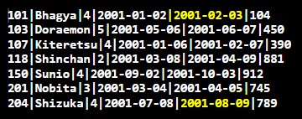

**Q2)** Create a table **Employee** with fields

EmpID Number (6) Primary key

Name Character (25)

Department Character (30)

Manager ID Number (6)

JoiningDate Date

Salary Number (8)

Insert 10 Rows in the above created table.

**SQL-Code [**SQLite 3.29.0**]:**

BEGIN TRANSACTION;

CREATE TABLE EMPLOYEE(

    emp_id integer PRIMARY KEY,

    emp_name text,

    department text,

    manager_id integer,

*-- YEAR MONTH DAY [Important Mistake!]*

    joining_date DATE,

    salary integer

);

*-- Insert 10 Rows in the above created table.*

INSERT INTO EMPLOYEE VALUES(

    4123,

    'Ninja_Hatori',

    'Production',

    1002,

    '2020-04-01',

    65000

);

INSERT INTO EMPLOYEE VALUES(

    4129,

    'Garfield',

    'Research',

    1027,

    '2018-04-02',

    45000

);

INSERT INTO EMPLOYEE VALUES(

    4230,

    'Mickey',

    'Marketing',

    1022,

    '2020-04-03',

    35000

);

INSERT INTO EMPLOYEE VALUES(

    4428,

    'Kiteretsu',

    'Accounting',

    1002,

    '2019-04-04',

    75000

);

INSERT INTO EMPLOYEE VALUES(

    4073,

    'Shizuka',

    'HR',

    1027,

    '2020-04-05',

    60000

);

INSERT INTO EMPLOYEE VALUES(

    4983,

    'Mr.Bean',

    'HR',

    1002,

    '2017-04-06',

    100000

);

INSERT INTO EMPLOYEE VALUES(

    4009,

    'Nobita',

    'Research',

    1022,

    '2015-04-07',

    50000

);

INSERT INTO EMPLOYEE VALUES(

    4773,

    'Doraemon',

    'Marketing',

    1042,

    '2020-04-08',

    25000

);

INSERT INTO EMPLOYEE VALUES(

    4833,

    'Gian',

    'Accounting',

    1102,

    '2018-04-09',

    95000

);

INSERT INTO EMPLOYEE VALUES(

    4337,

    'Donald',

    'HR',

    1082,

    '2020-04-10',

    55000

);

*-- Saving the Work*

COMMIT;

*-- 1. Employee table with all columns and rows.*

SELECT * FROM EMPLOYEE;

*-- 2. Employee details with columns Name and Department only.*

SELECT emp_name, department FROM EMPLOYEE;

*-- 3. Employee details of all the Employees who are in HR department.*

SELECT * FROM EMPLOYEE where department=='HR';

*-- 4. Employee details of all the Employees whose salary is between 50000 to 100000.*

SELECT * FROM EMPLOYEE WHERE salary>=50000 and salary<=100000;

*-- 5. Employee details of all the Employees whose JoiningDate is greater than 1st jan 2020.*

SELECT * FROM EMPLOYEE WHERE joining_date > '2020-01-01';

Display the below details.

1. Employee table with **all columns and rows**.

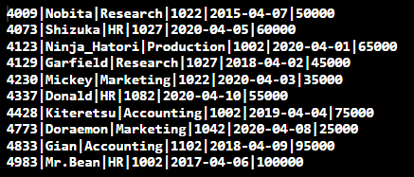

2. Employee details with columns **Name** and **Department** only.



3. Employee details of all the Employees who are in **HR** department.

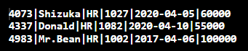

4. Employee details of all the Employees whose **salary** is between **50000 to 100000**.

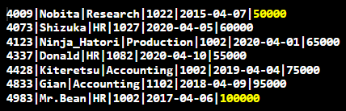

5. Employee details of all the Employees whose **JoiningDate** is greater than **1st jan 2020**.

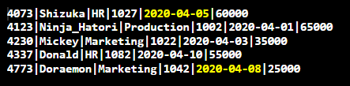

**Submitted By:**

**BHAGYA VINOD RANA**

**U19CS012**